Handout for NS fall 13

* Master controlling and communicating system of body
* Cells communicate via electrical and chemical signals
  + Rapid and specific
  + Usually cause almost immediate responses

**Functions of the Nervous System**

* **Sensory input**
  + Information gathered by sensory receptors about internal and external changes
* **Integration**
  + Processing and interpretation of sensory input
* **Motor output**
  + Activation of **effector** organs (muscles and glands) produces a response

See figure of level of organization. Division of Nervous system

**Histology of Nervous Tissue**

* Highly cellular; little extracellular space
  + Tightly packed
* Two principal cell types
  + **Neuroglia** – small cells that surround and wrap delicate neurons
  + **Neurons (nerve cells)**—excitable cells that transmit electrical signals

**Histology of Nervous Tissue: Neuroglia**

* **Astrocytes (CNS)**
* **Microglial cells (CNS)**
* **Ependymal cells (CNS)**
* **Oligodendrocytes (CNS)**
* **Satellite cells (PNS)**
* **Schwann cells (PNS)**

**Astrocytes: Forms the blood brain barrier**

* Most abundant, versatile, and highly branched glial cells
* Cling to neurons, synaptic endings, and capillaries
* Functions include
  + Support and brace neurons
  + Play role in exchanges between capillaries and neurons
  + Guide migration of young neurons
  + Control chemical environment around neurons
  + Respond to nerve impulses and neurotransmitters
  + Influence neuronal functioning
    - Participate in information processing in brain

**Microglial Cells: cleans the organ, tissue**

* Small, ovoid cells with thorny processes that touch and monitor neurons
* Migrate toward injured neurons
* Can transform to phagocytize microorganisms and neuronal debris

**Ependymal Cells: forms csf and moves it.**

* Range in shape from squamous to columnar
* May be ciliated
* Cilia beat to circulate CSF
* Line the central cavities of the brain and spinal column
* Form permeable barrier between cerebrospinal fluid (CSF) in cavities and tissue fluid bathing CNS cells

**Oligodendrocytes: forms the myelin sheath**

* Branched cells
* Processes wrap CNS nerve fibers, forming insulating **myelin sheaths** thicker nerve fibers

**Satellite Cells and Schwann Cells**

* Satellite cells
  + Surround neuron cell bodies in PNS
  + Function similar to astrocytes of CNS
* Schwann cells (neurolemmocytes)
  + Surround all peripheral nerve fibers and form myelin sheaths in thicker nerve fibers
    - Similar function as oligodendrocytes
  + Vital to regeneration of damaged peripheral nerve fibers

**Neurons**

* Structural units of nervous system
* Large, highly specialized cells that conduct impulses
* Extreme longevity (→ 100 years or more)
* Amitotic—with few exceptions
* High metabolic rate—requires continuous supply of oxygen and glucose
* All have **cell body** and one or more processes

**Nuclei –** clusters of neuron cell bodies in CNS

* **Ganglia** – lie along nerves in PNS
* Armlike processes extend from body
* CNS
  + Both neuron cell bodies and their processes
* PNS
  + Chiefly neuron processes
* **Tracts**
  + Bundles of neuron processes in CNS
* **Nerves**
  + Bundles of neuron processes in PNS
* Two types of processes
  + **Dendrites**
  + **Axon**

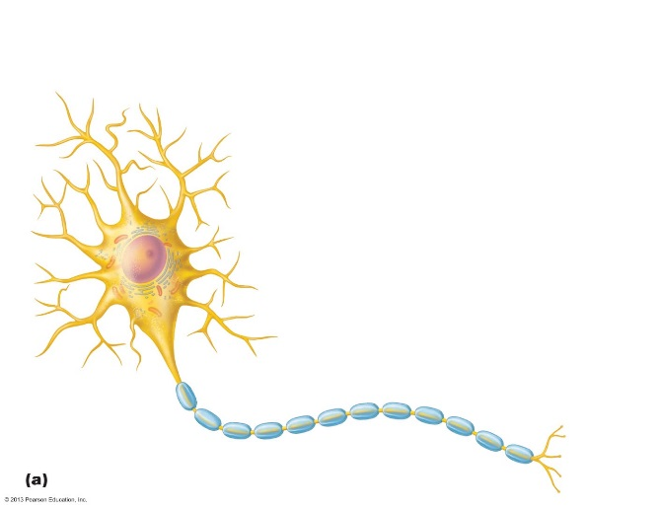

* **The Axon: Structure : axon hillock, nerve fibers**

**axon collaterals, axon terminals**

* **Myelin Sheath:** **Composed of myelin**
  + **Whitish, protein-lipoid substance**
  + **Myelinated fibers**

**Nonmyelinated fibers**

**Myelination in the PNS:**

* **Myelin Sheaths in the CNS:**
* **White matter**
  + **Regions of brain and spinal cord with dense collections of myelinated fibers – usually fiber tracts**

**Gray matter: Mostly neuron cell bodies and nonmyelinated fibers**

**Structural Classification of Neurons**

* **Grouped by number of processes**
* **Three types**
  + **Multipolar – 3 or more processes**
    - **1 axon, others dendrites**
    - **Most common; major neuron in CNS**
  + **Bipolar – 2 processes**
    - **1 axon and 1 dendrite**
    - **Rare, e.g., Retina and olfactory mucosa**
  + **Unipolar – 1 short process**
    - **Divides T-like – both branches now considered axons** 
      * **Distal (peripheral) process – associated with sensory receptor**
      * **Proximal (central) process – enters CNS**

**Functional Classification of Neurons**

* **Three types** 
  + **Sensory (afferent)**
  + **Motor (efferent)**
  + **Interneurons**

**Membrane Potentials**

* Neurons are highly excitable
* Respond to adequate stimulus by generating an **action potential** (nerve impulse)
* Impulse is always the same regardless of stimulus

Basic principle of electricity: read and understand.

**Role of Membrane Ion Channels**

**Gated channels**

* Three types
  + **Chemically gated** (**ligand-gated**) channels
    - Open with binding of a specific neurotransmitter
  + **Voltage-gated** channels
    - Open and close in response to changes in membrane potential
  + **Mechanically gated** channels
    - Open and close in response to physical deformation of receptors, as in sensory receptors

**The Resting Membrane Potential**

**Membrane polarized**

**Depolarization**

**Hyperpolarization**

**Action Potentials (AP)**

**Properties of Gated Channels**

* Each Na+ channel has two voltage-sensitive gates
  + **Activation gates**
    - Closed at rest; open with depolarization allowing Na+ to enter cell
  + **Inactivation gates**
    - Open at rest; block channel once it is open to prevent more Na+ from entering cell
* Each K+ channel has one voltage-sensitive gate
* Closed at rest
* Opens slowly with depolarization

**Threshold**

* Repolarizing phase

**Hyperpolarization**

**Role of the Sodium-Potassium Pump**

**The All-or-None Phenomenon**

**Propagation of an Action Potential**

**Absolute Refractory Period**

**Relative Refractory Period**

**Multiple Sclerosis (MS)**

**The Synapse**

**Synapse Classification**

**Important Terminology**

**Varieties of Synapses: Electrical Synapses, Chemical synapses**

**Synaptic Cleft**

**Information Transfer Across Chemical Synapses**

**Neurotransmitters**

**Chemical Structure**

**Classification of Neurotransmitters**

**Types and some examples**

**Function**

**Neurotransmitter Receptors**